**Spring Break TRIO Service Project: Feed My Starving Children**VANG LOR & CANDACE HER  
[uf9344jg@metrostate.edu](mailto:uf9344jg@metrostate.edu) & [ys6328ux@metrostate.edu](mailto:ys6328ux@metrostate.edu)

On March 9, 2017, TRIO Student Support Services took 14 TRIO students and two staff members on a volunteer service trip. The service trip was to Feed My Starving Children (FMSC) in Eagan, MN. When we first got there we learned about the non-profit organization and their mission. Feed My Starving Children is a Christian non-profit organization that hand packs meals for children that are in need. After the meals are prepped and boxed up, FMSC teams up with different organizations and distributes them throughout world. The meals consist of rice, soy, dried vegetables and a nutritionally complete blend of vitamins and minerals. FMSC has three permanent sites, located in Minnesota, Illinois and Arizona, and is open year-round, 6 days a week.

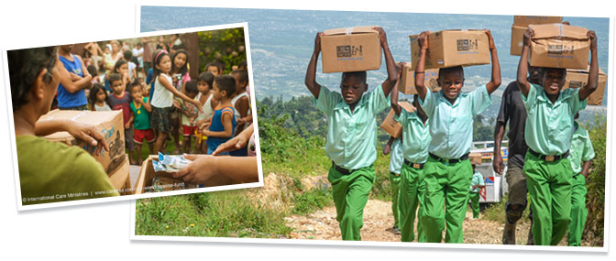

(Photo by: Feed My Starving Children website)

After a quick presentation, all the volunteers were put into teams. Everyone had a role in preparing the meals to achieve the goal. It starts with the scoopers that fill the meal bags with the different types of food. Then it goes to the group that weighs the meals to ensure the bag isn’t too heavy or too light. After that process, it goes to the sealer, who makes sure that there isn’t any excess air and that the meals are sealed tight. After sealing the meals, they are sent to packaging, where a label is applied to show where the package is coming from. The packers also make sure there are 36 meals in a box. The meals are then put onto a pallet and are ready to be shipped out to the different countries.

Overall, it was a great experience. We learned about the FMSC and their mission. We were also fortunate enough for FMSC to share their success stories with us. One personal thing we gained from this was learning how to work together as a team to achieve a global goal. It takes many helping hands to achieve something great. Within that two hours of volunteering, TRIO Student Support Services and other volunteers generated 112 boxes with a total of 24,192 meals. Those meals will help feed up to 67 kids for a year. Even though we were only there for a short time, with this little act of volunteering we were able to impact so many lives.

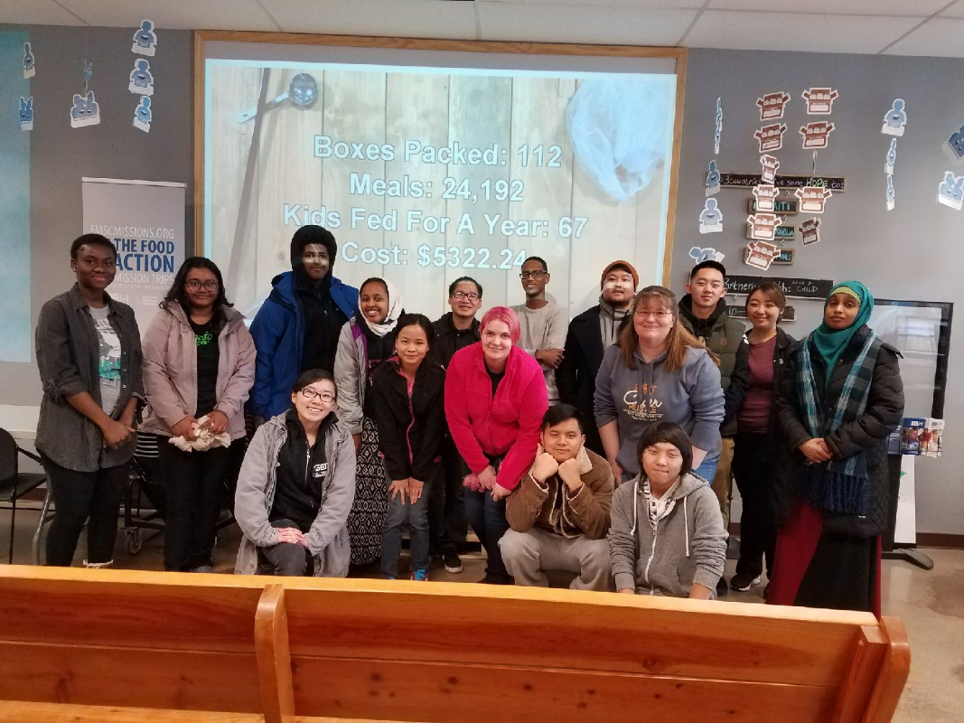

(Photo by: PaYong Xiong)